Lab10

16307130207 朱晓阳

Exercise 7

Screen shot 1:

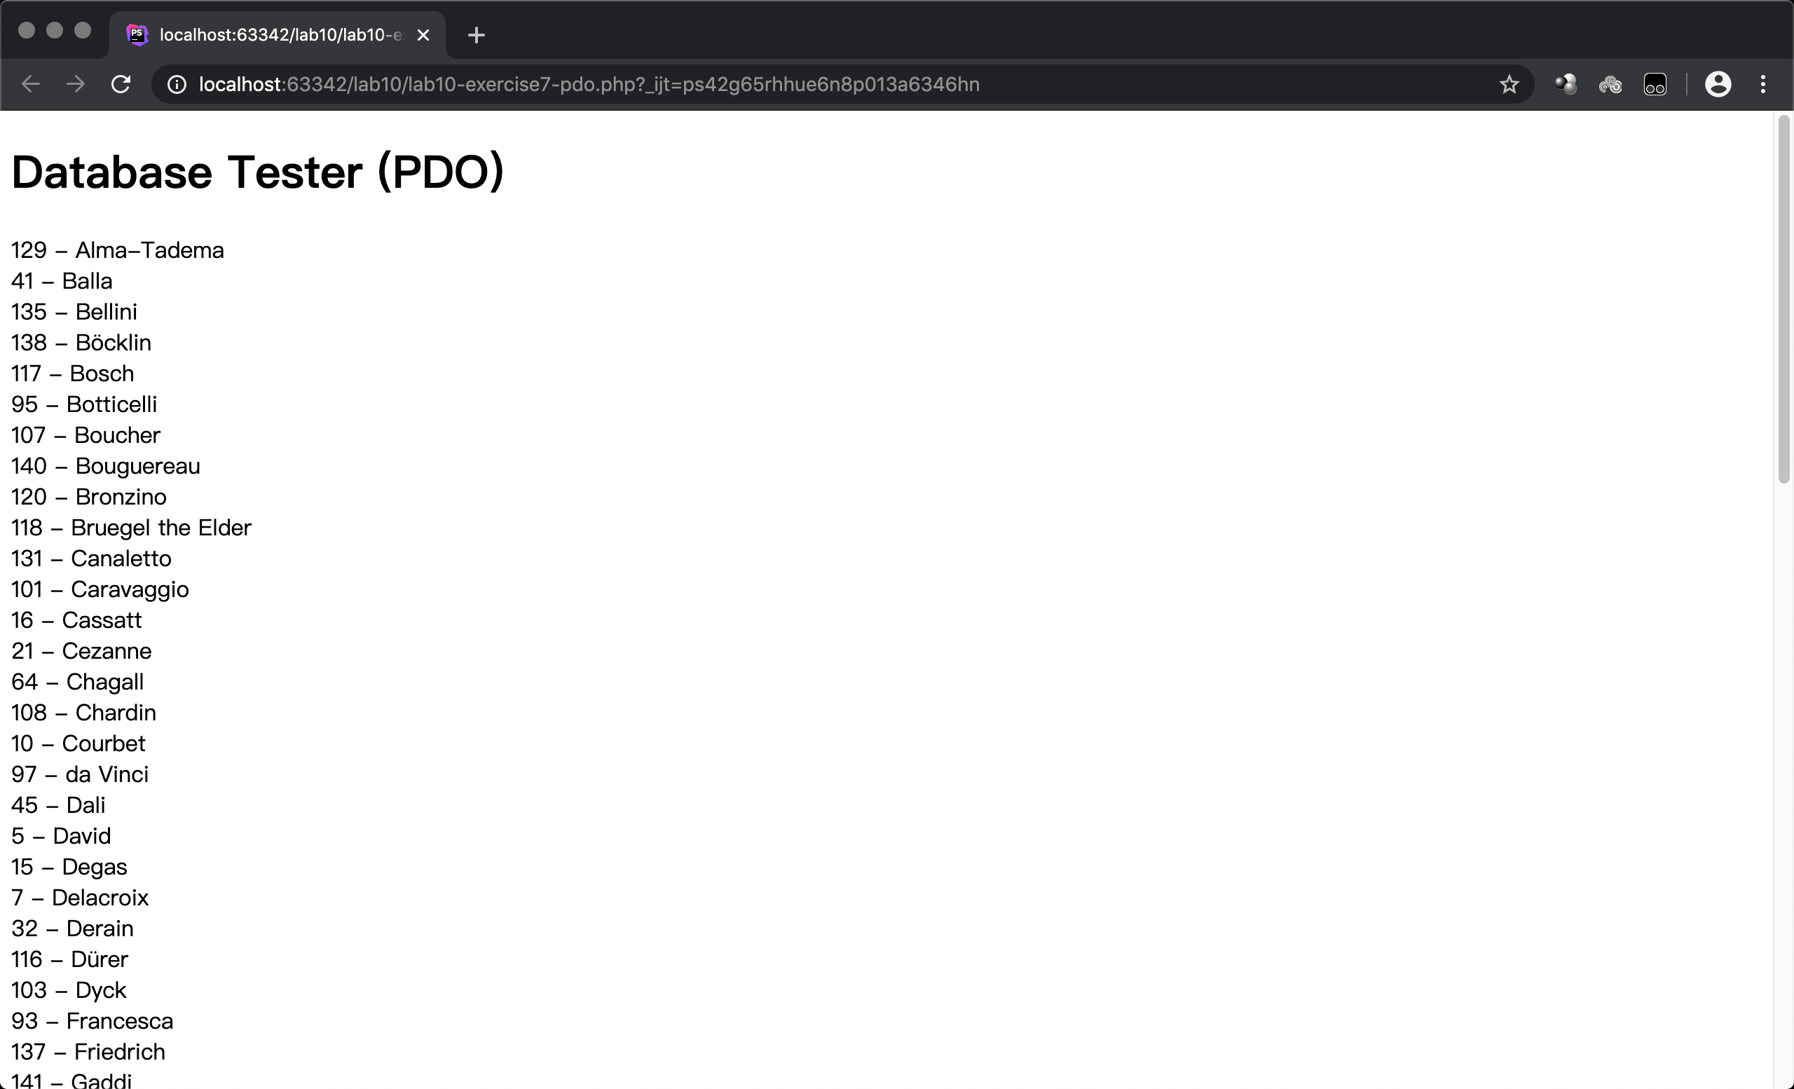

This part of the code connect to the database using username and password, then execute the mysql query: select *\** from Artists order by LastName , and store the result into the $result, go through the $result and print every row.

Screen shot 2

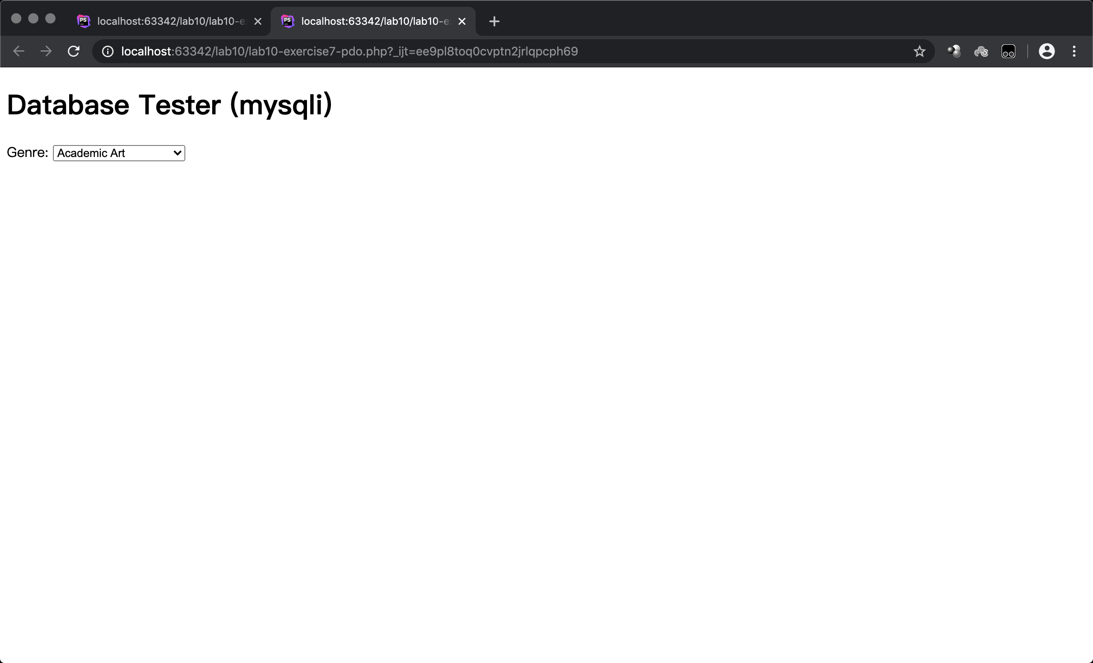

This part of the code connect to the database using username and password, then execute the mysql query: select *\** from Genres order by GenreName , and store the result into the $result, go through the $result and put the GenresID into an option list.

Exercise 8

Screen shot :

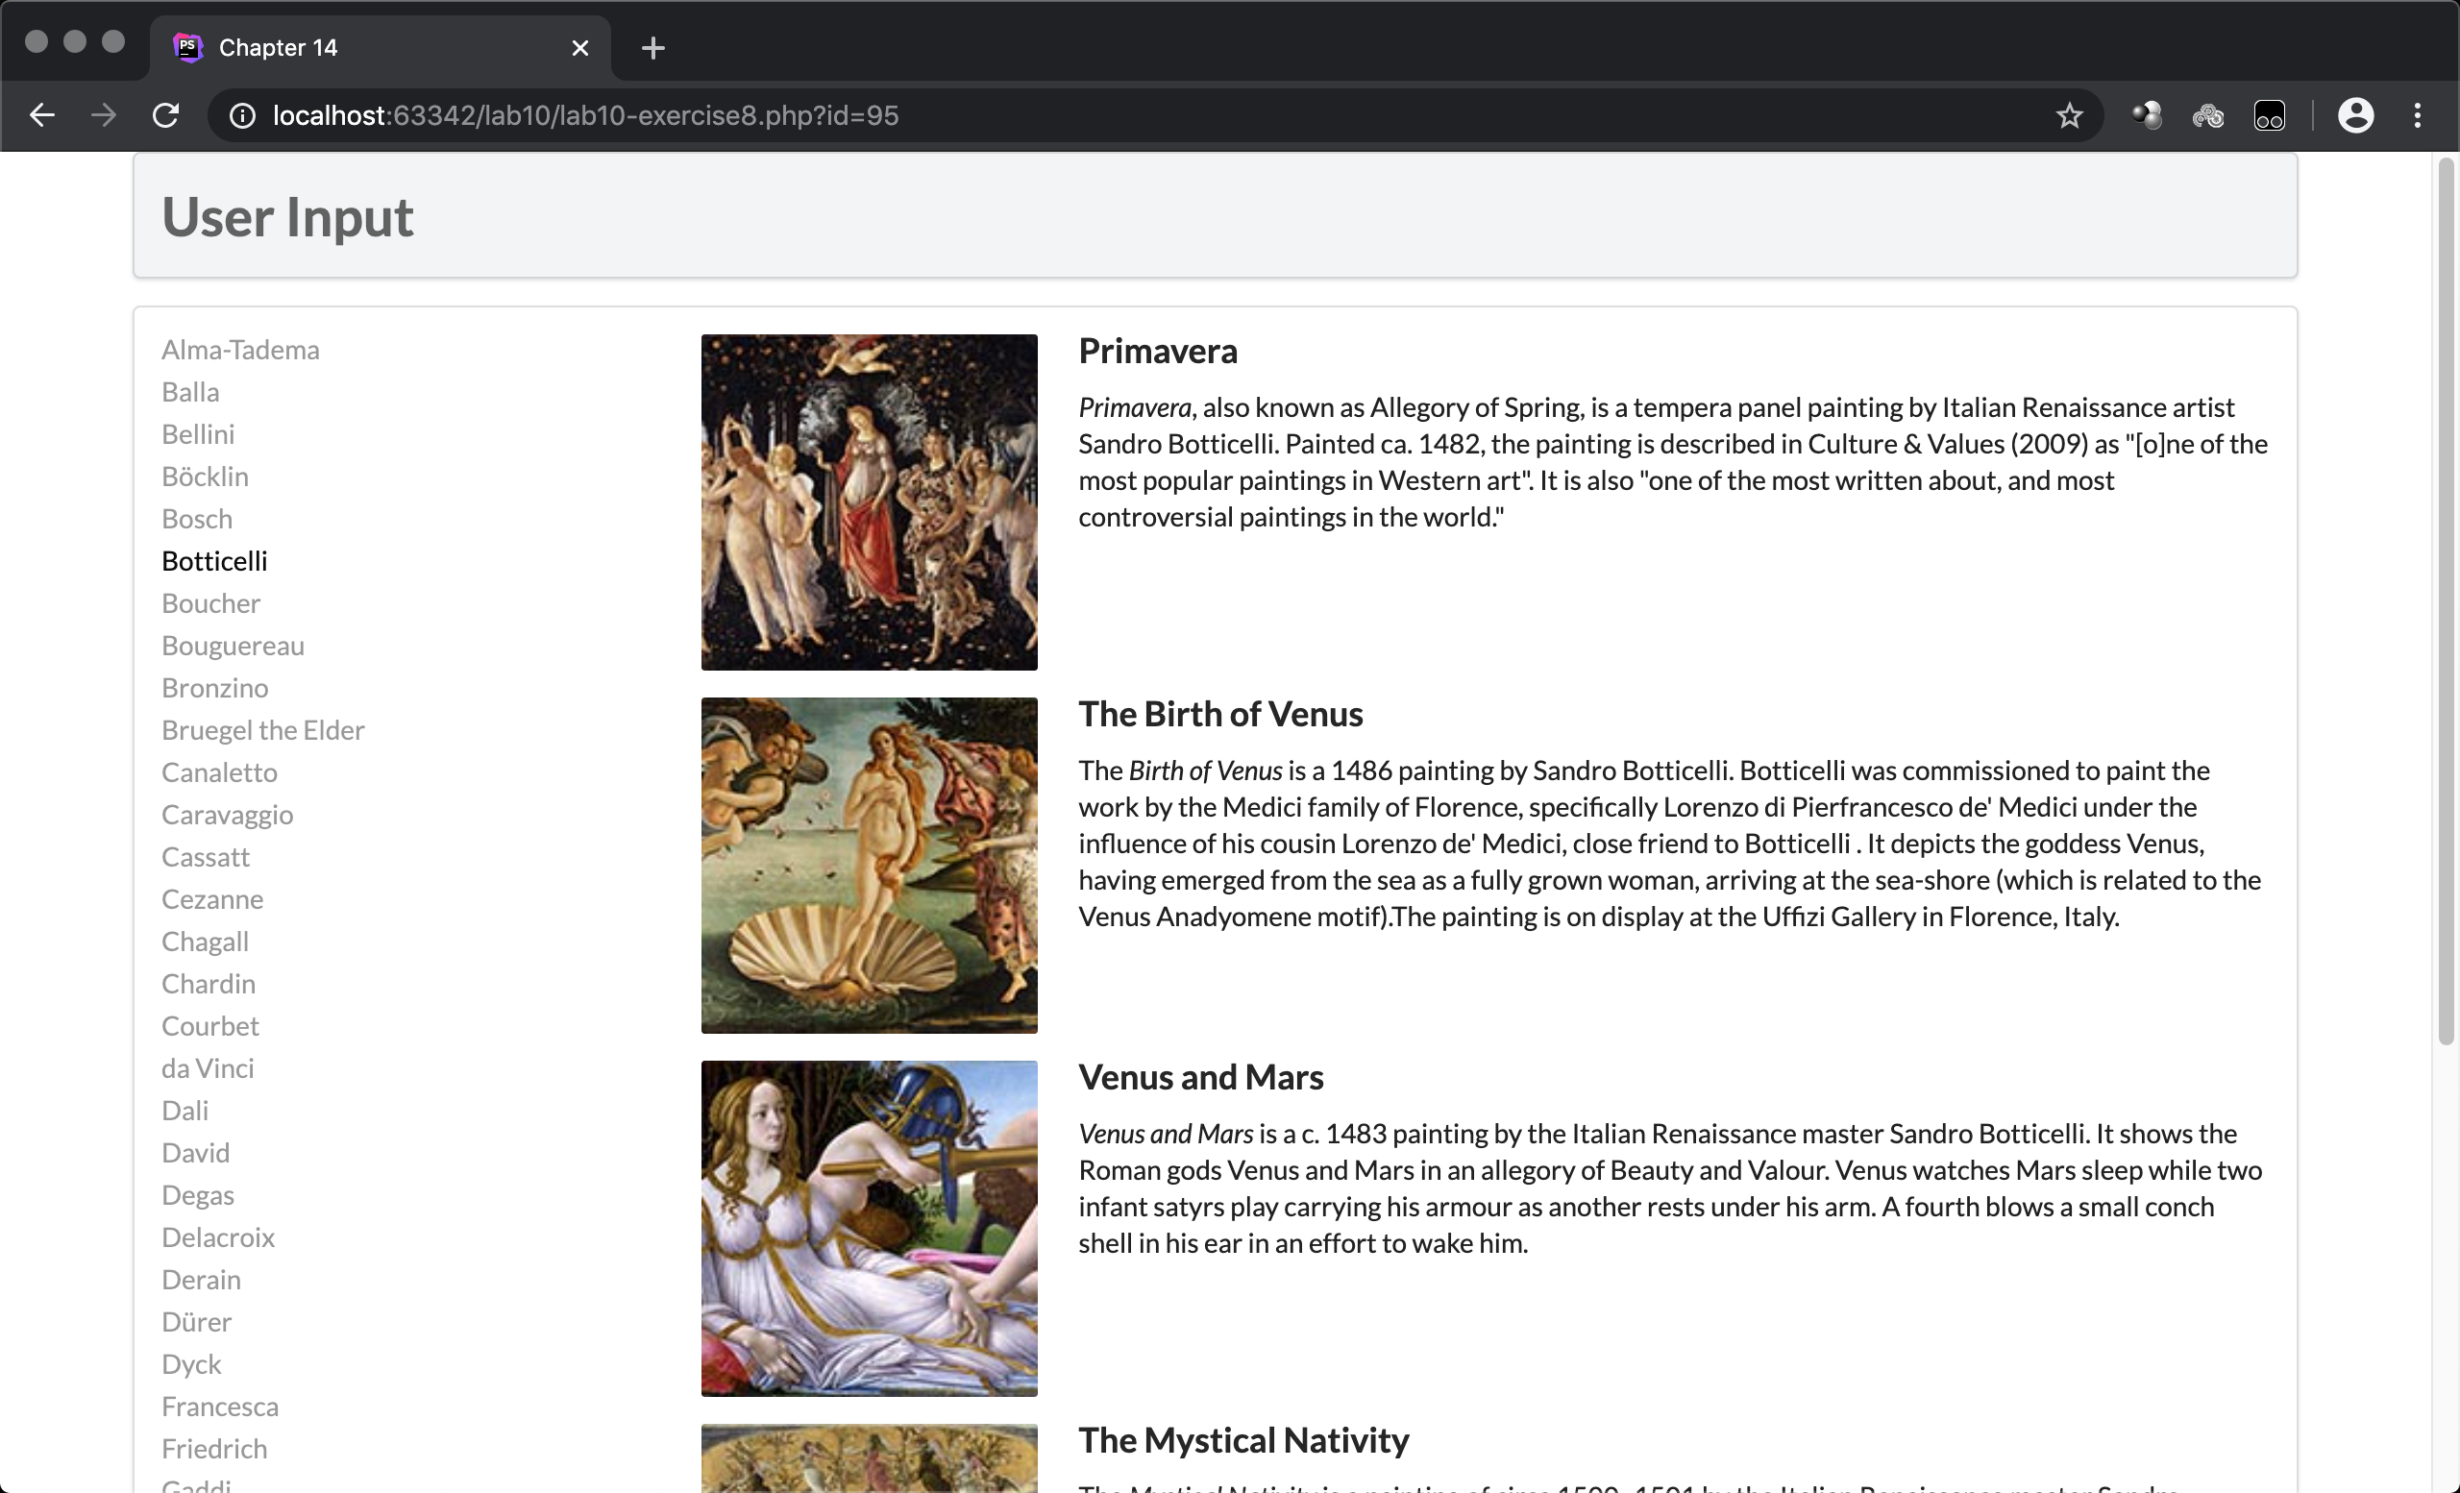

Paint the page first, which contains two divs: user input and the main window, in the main window, query the database with: select *\** from Artists order by LastName limit 0,30 and show the ArtistID in the main window, when clicked, find the detail information of this line and show on the left.

Exercise 9

Screen shot :

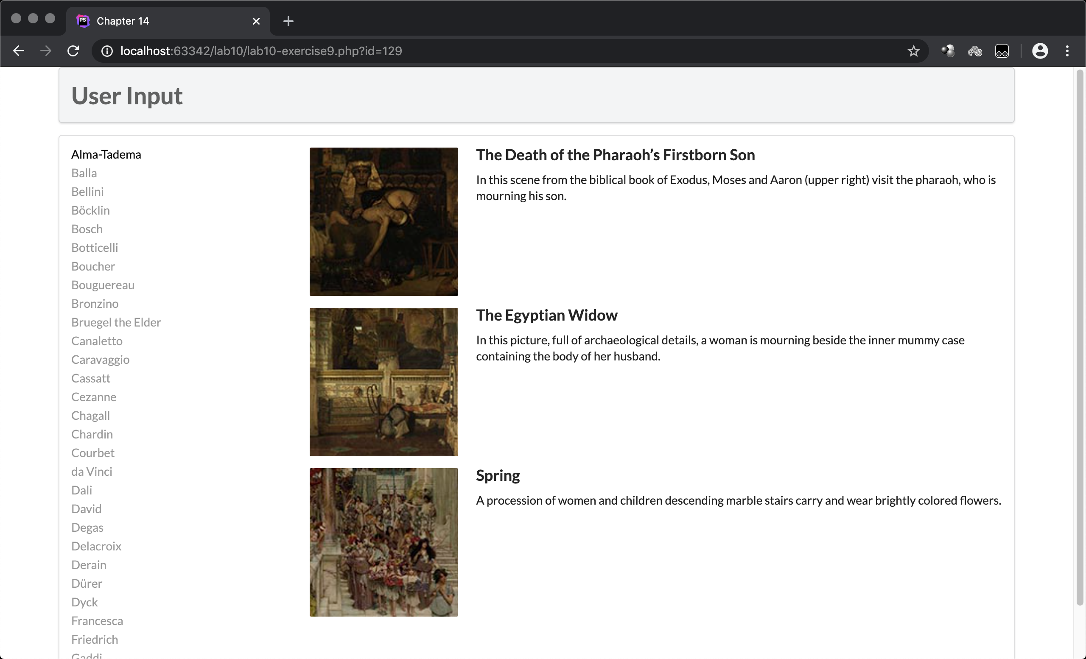

The other functions are just like exercise 8, but in function outputPaintings, a variable $statement was build to execute the mysql query.

Exercise 10

Screen shot :

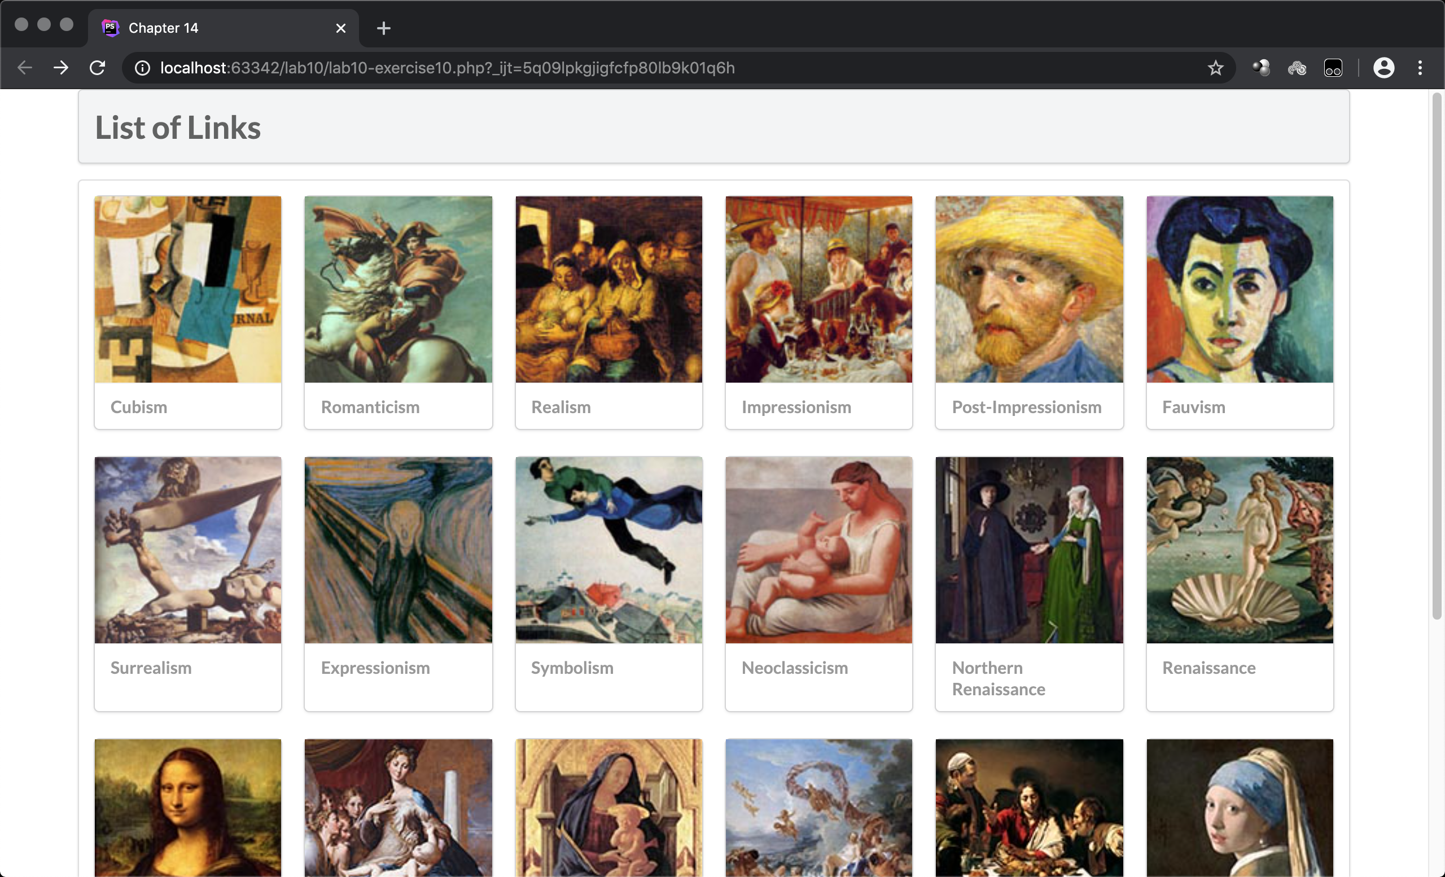

Select the Genre database and show some on the main page, when clicked, show more on a new page.